Review: Stationary Time Series Models
White noise process, covariance stationary process, AR(p), MA(p) and ARIMA processes, stationarity conditions, diagnostic checks.

White noise process 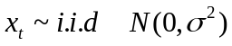
A sequence 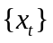is a white noise process if each value in the sequence has
- zero-mean 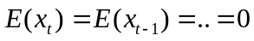
- constant conditional variance 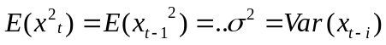
- is uncorrelated with all other realizations

Properties 1&2 : absence of serial correlation or predictability
Property 3 : Conditional homoscedasticity (constant conditional variance).

Covariance Stationarity (weakly stationarity)
A sequence is covariance stationary if the mean, var and autocov do not grow over time, i.e. it has
- finite mean 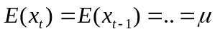
- finite variance
- finite autocovariance

Ex. autocovariance between 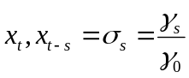

But white noise process does not explain macro variables characterized by persistence so we need AR and MA features.

Application:
plot wn and lyus
Program: whitenoise.prg
workfile: usuk.wf –page 1

The program generates and plots log of US real disposable income and a white noise process WN, based on the sample mean and variance of log US income (nrnd=normal random variable with 0 mean and SD of 0.36)

lyus=log(uspdispid)
WN= 8.03+0.36*nrnd

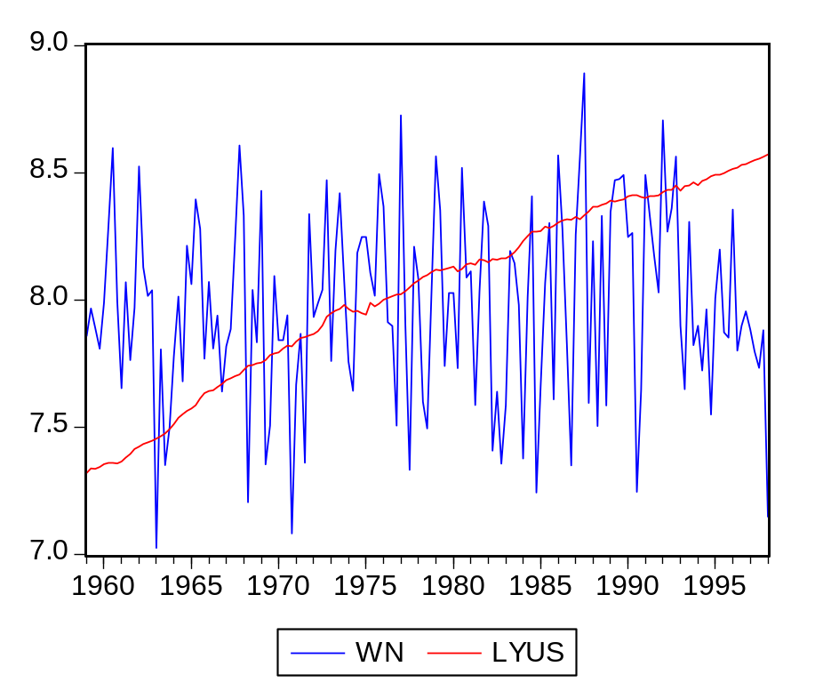

AR(1): 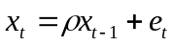 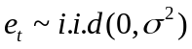, (random walk: 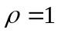)
MA(1): 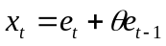

More generally:
AR(p): 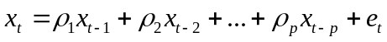
MA(q): 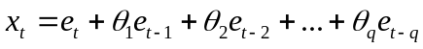
ARMA(p,q):

Using the lag operator:
AR(1): 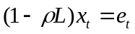
MA(1): 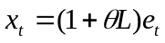
AR(p):
MA(q):
ARMA(p,q): 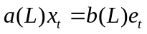

1. AR process
Stationarity Conditions for an AR(1) process
with 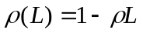 and substituting for L: 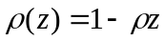

The process is stable if 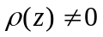 for all numbers satisfying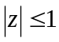. Then we can write
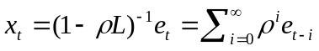

If x is stable, it is covariance stationary:
- 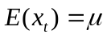 or 0 – finite
- 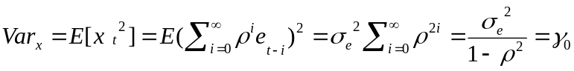 -- finite
- covariances
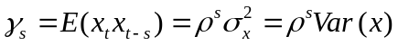

Autocorrelations between 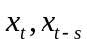:
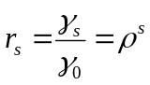

Plot of over time = Autocorrelation function (ACF) or correlogram.

For stationary series, ACF should converge to 0:
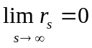 if 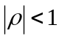
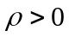 → direct convergence
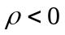 → dampened oscillatory path around 0.

Partial Autocorrelation (PAC)
Ref: Enders Ch.2

In AR(p) processes all x’s are correlated even if they don’t appear in the regression equation.
Ex: AR(1)
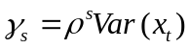
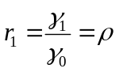; 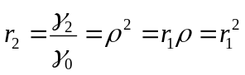; 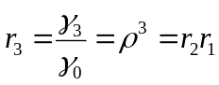

We want to see the direct autocorrelation between 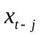and 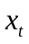by controlling for all x’s between the two. For this, construct the demeaned series and form regressions to get the PAC from the ACs.
1st PAC:
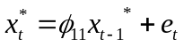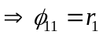

2nd PAC:
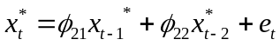 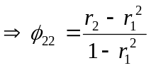.

In general, for 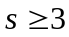, s^{th} PAC:
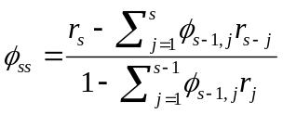 and 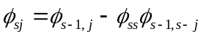.

Ex: for s=3, 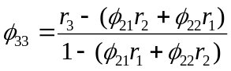.

Identification for an AR(p) process
PACF for s>p: 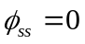

Hence AR(1): 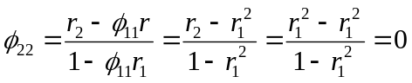

To evaluate it, use the relation :
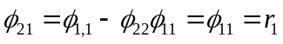, substitute it to get:
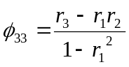 = 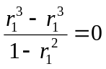

Stability condition for an AR(p) process
The process is stable if for all z satisfying , or if the roots of the characteristic polynomial lie outside the unit circle. Then, we can write:
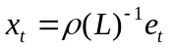 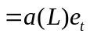 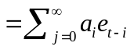.

Then we have the usual moment conditions:
- or 0 – finite
- 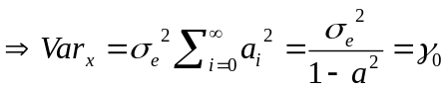 -- finite variance, hence time independent.

- covariances
=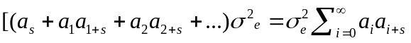 finite and time independent.
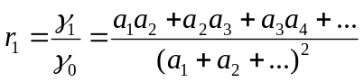
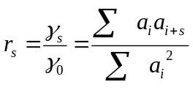

If the process is nonstationary, what do we do?
Then there is a unit root, i.e. the polynomial has a root for z=1 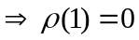. We can thus factor out the operator and transform the process into a first-difference stationary series:
-- an AR(p-1) model.

If has all its roots outside the unit circle, 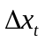is stationary: 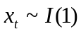

If 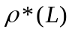still has a unit root, we must difference it further until we obtain a stationary process: 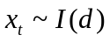

An integrated process = a unit root process.
- unconditional mean is still finite but
- Variance is time dependent
- Covariance is time dependent
(more later).

Application: generate an AR(1) series
Program: ARMA.prg
Workfile: USUK.wf, page 2 (undated)

Program:
smpl 1 1
genr x=0
smpl 2 200
series x=0.5*x(-1)+NRND '
'nrnd=normal random variable with 0 mean and SD of 0.36

Go to workfile, Click on: series – graph -- line

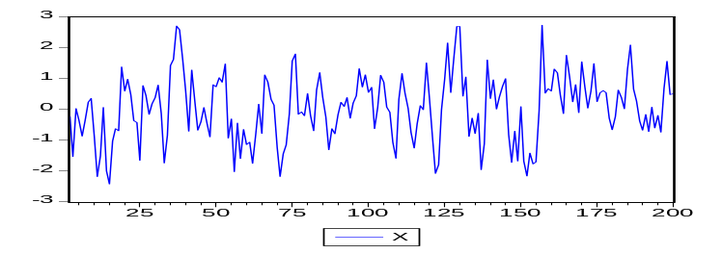

On series, click on View – Correlogram, level – OK

Date: 09/04/07 Time: 19:43
Sample: 2 200
Included observations: 199
Autocorrelation | Partial Correlation |  | AC | PAC | Q-Stat | Prob
.|**** | | .|**** | | 1 | 0.537 | 0.537 | 58.316 | 0.000
.|** | | .|. | | 2 | 0.257 | -0.045 | 71.715 | 0.000
.|* | | *|. | | 3 | 0.074 | -0.065 | 72.832 | 0.000
.|. | | .|. | | 4 | 0.003 | -0.002 | 72.834 | 0.000
*|. | | *|. | | 5 | -0.078 | -0.087 | 74.074 | 0.000
*|. | | .|. | | 6 | -0.087 | -0.007 | 75.654 | 0.000
*|. | | .|. | | 7 | -0.059 | 0.015 | 76.369 | 0.000
.|. | | .|. | | 8 | -0.029 | -0.002 | 76.549 | 0.000
.|. | | .|. | | 9 | 0.013 | 0.036 | 76.586 | 0.000
*|. | | *|. | | 10 | -0.081 | -0.156 | 77.970 | 0.000
.|. | | .|* | | 11 | -0.015 | 0.113 | 78.017 | 0.000
.|. | | .|. | | 12 | 0.010 | 0.000 | 78.039 | 0.000
.|* | | .|* | | 13 | 0.076 | 0.071 | 79.294 | 0.000
.|* | | .|. | | 14 | 0.101 | 0.051 | 81.484 | 0.000

ACF=0 at lag 3 and PAC=0 at lag 2 hence AR(1).
On Eviews: Q stats=Ljun-Box Q statistics and their p-values. H0: there is no autocorrelation up to lag k, asymptotically distributed as 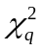, q=# autocorrelations.
Dotted lines: 2 SE bounds calculated approximately as 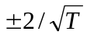, T=# observations.
Here: T=199 hence SE bounds =0.14.

Program:
smpl 1 1
genr xa=0
smpl 2 200
series xa= -0.5*xa(-1)+NRND
rho=-0.5 → dampened oscillatory path.

smpl 1 1
genr w=0
smpl 2 200
series w=w(-1)+NRND

rho=1 → random walk → unit root.

2. MA process
, e = 0 mean white noise error term.
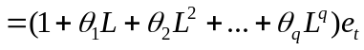 = 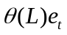

If 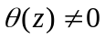 for , the process is invertible, and has an 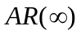representation:
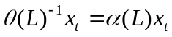 = 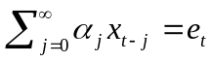 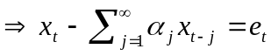
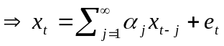

Stability condition for MA(1) process
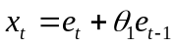
Invertibility requires 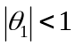
Then the AR representation would be:
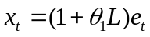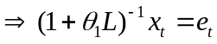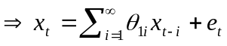

- 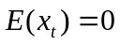 finite
- finite.
- 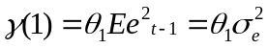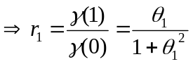
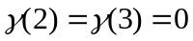 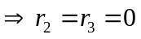, hence autocorrelations’ cut off point = lag 1
More generally : AC for MA(q)=0 for lag q.

- PAC:
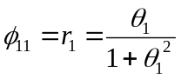
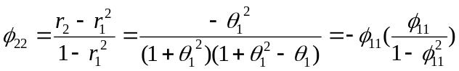
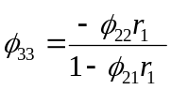 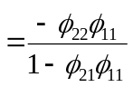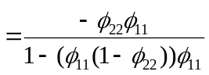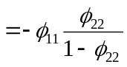 (?? check)

- For AR:
AC depends on the AC coefficient (rho), thus tapers off
PAC depends on or 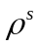, cuts of 0 at s (AR(1): cutoff at L=1)

- For MA:
AC depends on var of error terms: abrupt cutoff
PAC depends on the MA coefficient , thus tapers off.

3. ARMA process
ARMA(p,q): 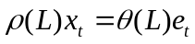
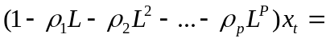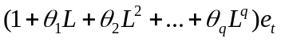

If q=0 → pure AR(p) process
If p=0 → pure MA(q) process

If all characteristics roots of 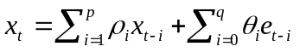 are within the unit circle, then this is an ARMA(p,q) process. If one or more roots lie outside the unit circle, then this is an integrated ARIMA(p,d,q) process.

Stability condition for ARMA(1,1) process
--Favero, p.37—

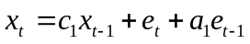
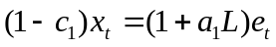 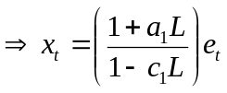.
If 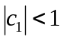 then we can write
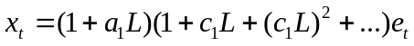
→ an 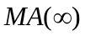 representation.

- finite
- 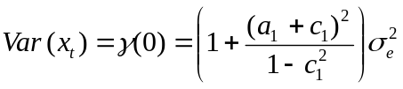 finite
- Covariances --finite
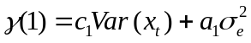
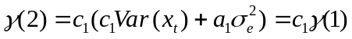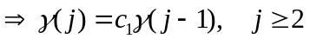

Autocov functions :
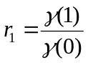
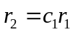
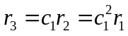

Any stationary time series can be represented with an ARMA model:
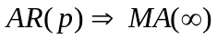
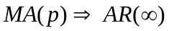

Application
Plot and ARMA(1,1) and an AR(1) model with rho=0.7 and theta=0.4, and look at the AC and PAC functions.
Prog: ARMA.prg
File: USUK, page 2.

smpl 1 1
genr zarma=0
genr zar=0
smpl 1 200
genr u=NRND
smpl 2 200
series zarma=0.7*x(-1)+u+0.4*u(-1)
series zar=0.7*x*(-1)
plot zarma zar
zarma.correl(36)
zar.correl(36)

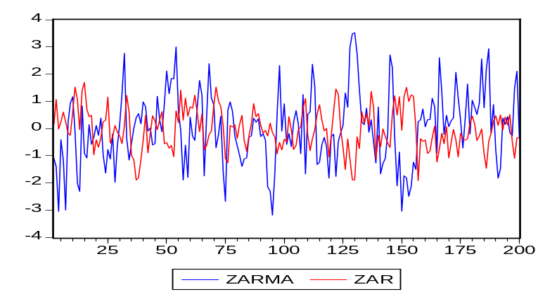

Summary of results
Enders Table 2.1

 | ACF | PACF
WN | 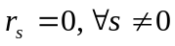 | 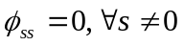
AR(1) | Exponential Decay:  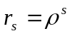  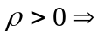direct decay  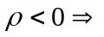oscillating | Spike at lag 1 (at p for AR(p))  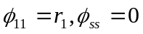 for 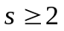
MA(1) | Positive (negative) spike  at lag 1 for 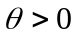 (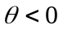)  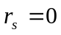 for | Oscillating (geometric) decay  for 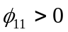 (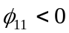)
ARMA(1,1) | Exponential (oscillating) decay  at lag 1 if 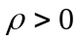 (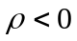).  Decay at lag q for ARMA(p,q) | Oscillating (exponential) decay  at lag 1, 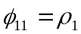  Decay after lag p for ARMA(p,q)

Stationary Time Series II

Model Specification and Diagnostic tests
E+L&K Ch 2.5,2.6

So far we saw the theoretical properties of stationary TS. To decide about the type of model to use, we need to decide about the order of operators (# lags), the deterministic trends, etc. We therefore need to specify a model and then conduct tests on its specification, whether it represents the DGP adequately.

1. Order specification criteria:

- The t/F-statistics approach: start from a large number of lags, and reestimate by reducing by one lag every time. Stop when the last lag is significant. Monthly data: look at the t-stats for the last lag, and F-stats for the last quarter. Then check if the error term is white noise.

- Information Criteria: AIC, HQ or SBC

Definition in Enders:

Akaike:
AIC=T.log(SSR)+2n

Schwarz:
SBC=T.log(SSR)+n.log(T) also called Schwartz and Risanen.

Hannan-Quinn:
HQC=T. log(SSR)+2n.log(log(T))

T=#observations, n=#parameters estimated, including the constant term.
Adding additional lags will reduce the SSR, these criteria penalize the loss of degree of freedom that comes along with additional lags.

The goal=pick the #lag that minimizes the information criteria.

Since ln(T)>2, SBS selects a more parsimonious model than AIC.
For large sample, HQC and in particular SBC is better than AIC since they have better large sample properties.
  - If you go along with SBC, verify that the error term is white noise. In small samples, AIC performs better.
  - If you go with AIC, then verify that the t-stats are significant. This is valid whether the processes are stationary or integrated.

Note: various software and authors use modified versions of these tests. As long as you use the criteria consistently among themselves, any version will give the same results.

For ex: definition by LK:
AIC=log(SSR) + 2(n/T)

SC= log(SSR) + n(logT/T)

HQ=log(SSR) + 2n.log(logT)/T)

Definition used in Eviews :
AIC=-2(l/T)+(2n/T)

SC=-2(l/T)+n(logT/T)

HQ=-2(l/T)+2n.log(logT)/T

where l is the log likelihood given by 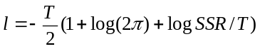 and is the constant of the log likelihood often omitted.

Denote the order selected by each criterion as . The following holds independent of the size of the sample:

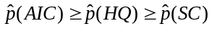

Word of warning:
It is difficult to distinguish between AR, MA and mixed ARMA processes based on sample information. The theoretical ACF and PACF are not usually replicated in real economic data, which have a complicated DGP. Look into other tests that analyze the residuals once a model is fitted:

2. Plotting the residuals:
Check for outliers, structural breaks, nonhomogenous variances.
- Look at standardized residuals (subtract the mean and divide by standard deviation): 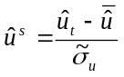 where 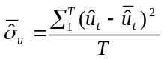 is the standard deviation and is the mean. If ~N(0,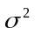) then 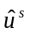 will be in general in a 2 band around the 0 line.
- Look at the AC and PAC to check the remaining serial residuals in the residuals, and AC of squared residuals to check for conditional heteroscedasticity. If the AC and PAC of earlier lags are not in general within 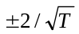band around 0 then there is probably left over serial dependence in the residuals or conditional heteroscedasticity.

3. Diagnostic tests for residuals:

i. Test of whether the kth order autocorrelation is significantly different from zero:
The null hypothesis: there is no residual autocorrelation up to order s
The alternative: there is at least one nonzero autocorrelation.

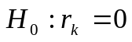 and k=1,..s
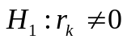 for at least one k=1,..s.

where 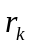 is the k-th autocorrelation.
If the null is rejected, then at least one r is significantly different from zero. The null is rejected for large values of Q. If there are any remaining residual autocorrelation, must use a higher order of lag.

- The Box-Pierce Q-statistics (Portemanteau test for residual autocorrelation)
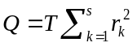 ~ 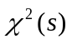

T=# observations.
But not reliable for small samples and it has reduced power for large s. Instead, use

- Ljung-Box Q statistics:

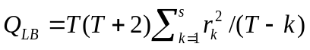

with similar null and alternative hypotheses.

It can also be used to check if the residuals from an estimated ARMA(p,q) model are white noise (adjust for the lags in AR(p) and MA(q)):
Q~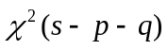 or 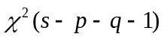 with a constant.

ii. Breusch-Godfrey (LM) test for autocorrelation for AR models for residuals:
It considers an AR(h) model for residuals.
Suppose the model you estimate is an AR(p):
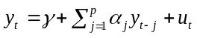

You fit an auxiliary equation
(*) 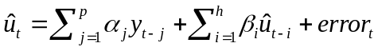 where 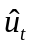u is the OLS residual from the AR(p) model for y.

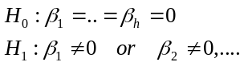

The LM statistics for the null: 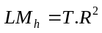~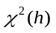, where 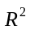is obtained from fitting (*).

For better small sample properties use an F version:

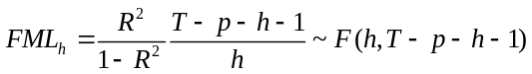

iii. Jarque-Bera test for nonnormality
It tests if the standardized residuals are normally distributed, based on the third and fourth moments, by measuring the difference of the skewness and the kurtosis of the series with those from the normal distribution.

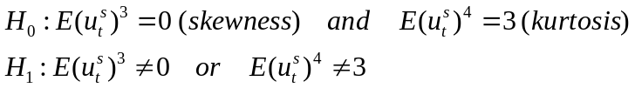

JB ~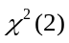 and the null is rejected if JB is large. In this case, residuals are considered nonnormal.

Note:
- most of the asymptotic results are also valid for nonnormal residuals.
- the results may be due to nonlinearities. Then you should look into ARCH effects or structural changes.

iv. ARCH-LM test for conditional heteroscedasticity
Fit an ARCH(q) model to the estimation of the residuals
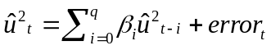 and test if

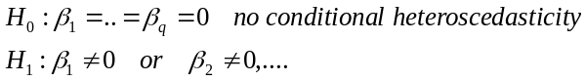

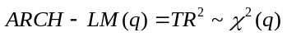. Large values of ARCH-LM show that the null is rejected and there are ARCH effects in the residuals. Then fit an ARCH or GARCH model.

v. RESET
Tests a model specification against alternatives (nonlinear).
Ex: you are estimating a model
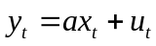
But the actual models is
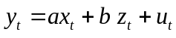
where z can be missing variable(s) or a multiplicative relation. The test checks if powers of predicted values of y is significant. These consist of the powers and cross-product terms of the explanatory variables:
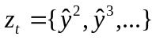

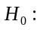b=0 --no misspecification

The test statistics has an F(h-1,T) distribution. The null is rejected if the test statistics is too large.

vi. Stability analysis
Recursive plot of residuals, of estimated coefficients;
CUSUM test (cumulative sum of recursive residuals): if the plot diverges significantly from the zero line, it suggests structural instability.
CUSUMSQR (square of CUSUM) in case there are several shifts in different directions.
Chow test: for exogenous break points.

Example:
Workfile: LKEdata.wf page--Enders
Series: US PPI
Plot the data:
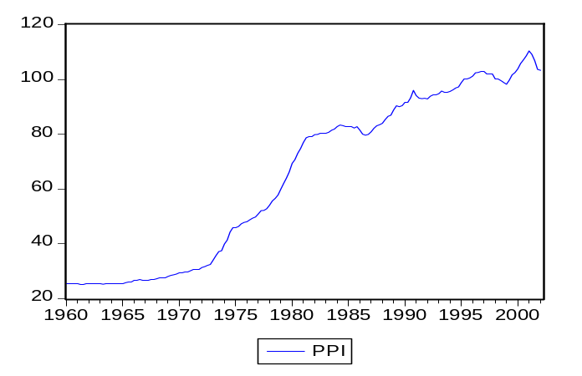

Positive trend in the series indicates nonstationarity.

Correlogram:

Date: 09/19/07 Time: 10:00
Sample: 1960Q1 2002Q2
Included observations: 169
Autocorrelation | Partial Correlation |  | AC | PAC | Q-Stat | Prob
.|******** | .|******** | 1 | 0.990 | 0.990 | 168.44 | 0.000
.|******** | .|. | | 2 | 0.978 | -0.044 | 334.05 | 0.000
.|*******| | *|. | | 3 | 0.966 | -0.071 | 496.37 | 0.000
.|*******| | .|. | | 4 | 0.952 | -0.056 | 655.05 | 0.000
.|*******| | .|. | | 5 | 0.937 | -0.036 | 809.87 | 0.000
.|*******| | .|. | | 6 | 0.923 | 0.003 | 960.86 | 0.000
.|*******| | .|. | | 7 | 0.908 | -0.003 | 1108.0 | 0.000
.|*******| | .|. | | 8 | 0.894 | -0.004 | 1251.5 | 0.000
.|*******| | .|. | | 9 | 0.880 | 0.009 | 1391.2 | 0.000
.|*******| | .|. | | 10 | 0.866 | -0.003 | 1527.5 | 0.000
.|*******| | .|. | | 11 | 0.852 | -0.011 | 1660.1 | 0.000
.|****** | | .|. | | 12 | 0.838 | 0.001 | 1789.4 | 0.000

The confidence intervals 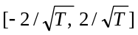=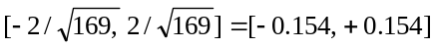
Q statistics highly significant, the residuals are not white noise. Need to respecify the model.
ACF dies out very slowly
PACF (the autocorrelation conditional on the in-between values of time series): single spike
Observation of the data suggests U.R. Hence we cannot use the models developed so far.

First difference dppi.
Plot: it seems to be stationary, though the variance does not look constant, increases in the second half of the sample.
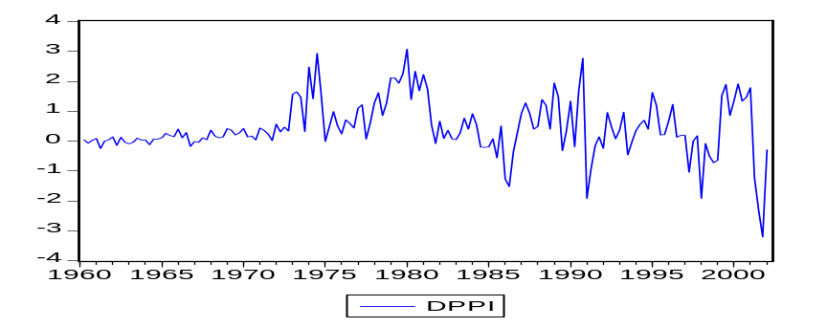

ACF dies out quickly after the 4th lag, and PACF has a large spike and dies out oscillating. Note the significant correlations and PAC at lag 6 and PAC at lag 8. This can be an AR(p) or an ARMA(p,q) process.

Included observations: 168
Autocorrelation | Partial Correlation |  | AC | PAC | Q-Stat | Prob
.|**** | | .|**** | | 1 | 0.553 | 0.553 | 52.210 | 0.000
.|*** | | .|. | | 2 | 0.335 | 0.043 | 71.571 | 0.000
.|** | | .|* | | 3 | 0.319 | 0.170 | 89.229 | 0.000
.|** | | .|. | | 4 | 0.216 | -0.042 | 97.389 | 0.000
.|* | | *|. | | 5 | 0.086 | -0.081 | 98.682 | 0.000
.|* | | .|* | | 6 | 0.153 | 0.149 | 102.82 | 0.000
.|* | | *|. | | 7 | 0.082 | -0.096 | 104.02 | 0.000
*|. | | *|. | | 8 | -0.078 | -0.149 | 105.10 | 0.000
*|. | | .|. | | 9 | -0.080 | -0.007 | 106.23 | 0.000
.|. | | .|* | | 10 | 0.023 | 0.121 | 106.33 | 0.000
.|. | | .|. | | 11 | -0.008 | 0.004 | 106.34 | 0.000
.|. | | .|. | | 12 | -0.006 | 0.007 | 106.35 | 0.000

In Eviews:
run equation dppi c AR(1)
(You can also run equation dppi c dppi(-1), but with the first specification Eviews estimates the model with a nonlinear algorithm, which helps controlling for nonlinearities if they exist in the DGP).

Dependent Variable: DPPI
Method: Least Squares
Date: 09/19/07 Time: 10:13
Sample (adjusted): 1960Q3 2002Q1
Included observations: 167 after adjustments
Convergence achieved after 3 iterations
Variable | Coefficient | Std. Error | t-Statistic | Prob.
C | 0.464364 | 0.133945 | 3.466835 | 0.0007
AR(1) | 0.554760 | 0.064902 | 8.547697 | 0.0000
R-squared | 0.306907 | Mean dependent var |  | 0.466826
Adjusted R-squared | 0.302706 | S.D. dependent var |  | 0.922923
S.E. of regression | 0.770679 | Akaike info criterion |  | 2.328814
Sum squared resid | 98.00107 | Schwarz criterion |  | 2.366155
Log likelihood | -192.4560 | F-statistic |  | 73.06313
Durbin-Watson stat | 2.048637 | Prob(F-statistic) |  | 0.000000
Inverted AR Roots | .55

Check the optimal lag length for an AR(p) process.
Check the roots: if it is <1, stability is confirmed. View-ARMA structure-roots shows you the root(s) visually.
View-ARMA structure-correlogram: allows you to compare the estimated correlations with the theoretical ones.
View-ARMA structure-impulse response: shows how the DGP changes with a shock of the size of one standard deviation.
View-Residual tests: to check if there is any residual autocorrelation left.

Optimal lag length:
lags | 1 | 2 | 3 | 10
AIC | 2.328814* | 2.565575 | 2.575278 | 2.735557
SBC | 2.366155* | 2.603069 | 2.612925 | 2.774324

It appears that AR(1) dominates the rest in terms of the information criteria.

Roots of AR(1):
0.55<1 –stability condition satisfied, since the root is inside the unit circle.
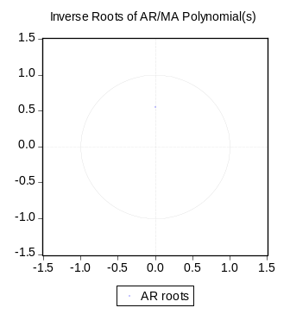

But serial correlation is a problem:

Breusch-Godfrey Serial Correlation LM Test:
F-statistic | 3.478636 | Prob. F(2,163) |  | 0.033159
Obs*R-squared | 6.836216 | Prob. Chi-Square(2) |  | 0.032774

High Q stats (correlogram), and the Godfrey-Breusch test 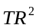=6.84>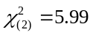 rejects the null at the 5% confidence interval, thus there is at least one 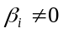. There is serial correlation in the error terms.

Lets try ARMA(p,q):
lags | 1,1 | 1,2 | 2,1
AIC | 2.3305* | 2.3366 | 2.345
SBC | 2.386* | 2.3926 | 2.402

Information criteria favor an ARMA(1,1) specification although the marginal change is very small. So we should consider all options.

ARMA (1,1) -- Eviews: equation dppi c ar(1) ma(1)

Included observations: 167 after adjustments
Convergence achieved after 9 iterations
Backcast: 1960Q2
Variable | Coefficient | Std. Error | t-Statistic | Prob.
C | 0.455286 | 0.163873 | 2.778280 | 0.0061
AR(1) | 0.730798 | 0.100011 | 7.307163 | 0.0000
MA(1) | -0.261703 | 0.139158 | -1.880622 | 0.0618
R-squared | 0.313995 | Mean dependent var |  | 0.466826
Adjusted R-squared | 0.305629 | S.D. dependent var |  | 0.922923
S.E. of regression | 0.769062 | Akaike info criterion |  | 2.330510
Sum squared resid | 96.99884 | Schwarz criterion |  | 2.386522
Log likelihood | -191.5976 | F-statistic |  | 37.53259
Durbin-Watson stat | 1.935301 | Prob(F-statistic) |  | 0.000000
Inverted AR Roots | .73
Inverted MA Roots | .26

Both roots inside the unit circle. AR and MA coefficients significant.
Some of the AC at larger lags are significant.
LM test: =5.29 <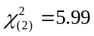 does not reject no serial correlation in the error terms.

Notice that if you estimate an ARMA(1,2) the MA coefficient is insignificant. Together with the information criteria, we can rule out this specification. The LM test results also do not support this specification.

Variable | Coefficient | Std. Error | t-Statistic | Prob.
C | 0.457550 | 0.176196 | 2.596826 | 0.0103
AR(1) | 0.807616 | 0.120152 | 6.721624 | 0.0000
MA(1) | -0.280755 | 0.148664 | -1.888526 | 0.0607
MA(2) | -0.152639 | 0.116160 | -1.314038 | 0.1907
R-squared | 0.322970 | Mean dependent var |  | 0.466826
Adjusted R-squared | 0.310509 | S.D. dependent var |  | 0.922923
S.E. of regression | 0.766355 | Akaike info criterion |  | 2.329317
Sum squared resid | 95.72980 | Schwarz criterion |  | 2.404000
Log likelihood | -190.4980 | F-statistic |  | 25.91910
Durbin-Watson stat | 2.011448 | Prob(F-statistic) |  | 0.000000
Inverted AR Roots | .81
Inverted MA Roots | .56 | -.27

ARMA (2,1) is better than ARMA(1,2) but does not dominate ARMA(1,1). The estimated coefficients are significant, but there is residual serial correlation.

We can perform additional tests to check the stability of the coefficient, seasonal effects, etc.

Seasonality
Cyclical movements observed in daily, monthly or quarterly data. Often it is useful to remove it if it is visible in lags s, 2s, 3s, …. of the ACF and the PACF. You add an AR or MA coefficient at the appropriate lag.

Possibilities:
Quarterly seasonality with MA at lag 4:
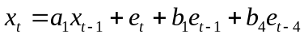

Quarterly seasonality with AR at lag 4:
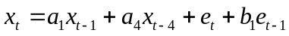

Multiplicative seasonality
Accounts for interaction of the ARMA and seasonal effects.

MA term at lag 1 interacting with the seasonal MA term at lag 4:
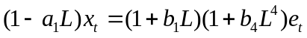

AR term at lag 1 interacting with the seasonal AR term at lag 4:
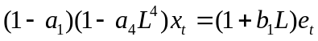

One solution to remove strong seasonality is to transform the data by seasonal differencing. For quarterly data:
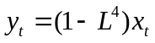
If the data is not stationary, then also need to first difference it:
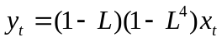

Eviews:
Several methodologies for seasonal adjustment

Series—Proc—Seasonal Adjustment
Census X12
Census 11
Moving Average Methods
Tramo-Seat method

The first two options allow additive or multiplicative specifications, control for holidays, trading days, outliers.

Homework: due September 26, 2007
Data: Enders Question 12.

